Weekly Report

# Summary:

Goals:

* Working Reception App for keeping track of the students in house and other information
* Working Light system
* Working air conditioning system (includes the smoke detector)
* Working Food management system
* Working Alarm system
* Working door locking system with RFID chips for check-in /check-out
* Creating a product that will be able to provide a better user experience and management system for the Student House or other similar facilities.

What we have done till now:

* Created a project plan
* Created a concept of the “Network architecture” (How the Modules are connected)
* Created a concept design for the “Reception App”
* Prototype of the “Reception App”
* Created the base code for the Light and Alarm Modules

What we are currently working on:

* Created the base code for the Air conditioning and Locking Modules
* New better design for the “Reception App”
* Working out the details of the “Network architecture”
* The way we are going to present the project
* The list for the necessary Elements (Boards, Shield, Sensors, etc.)

What we will be discussing in today’s meeting:

* Working out the details of the “Network architecture”
* The way we are going to present the project

# Hardware list:

Board:

1. Arduino compatible boards (Uno or Nano) – up to 6
2. Breadboards – up to 6

Sensors:

1. PIR motion sensor HC-SR501 - 1
2. Magnetic switch MC-38 – up to the number of Rooms (2)
3. GL5528 LDR Light Dependent Resistor -3
4. HC-SR04 Ultrasonic sensor - 1
5. DHT11 temperature and humidity sensor up to the number of Rooms (2)

Actuators:

1. SG90 Digital servo 360 degrees - 5

Other elements:

1. Resistor 470Ω for LED (color code yellow – purple – brown) Resistor 10KΩ for Button (color code brown – black – orange)
2. Breadboard jumper wires male – male
3. Breadboard jumper wires male – female
4. USB cable for Arduino – depending on the number of the arduinos
5. Potentiometer 10 KΩ – up to the number of Rooms (2)
6. Buzzer active sensor module KY-012 – 1 or 2
7. ESP8266 ESP-01 Serial Wireless WIFI Module depending on the number of the arduinos
8. RGB-LED diffuus 5 mm common cathode (ground) – min 3

# Graphs:

## Student House Module Diagram:

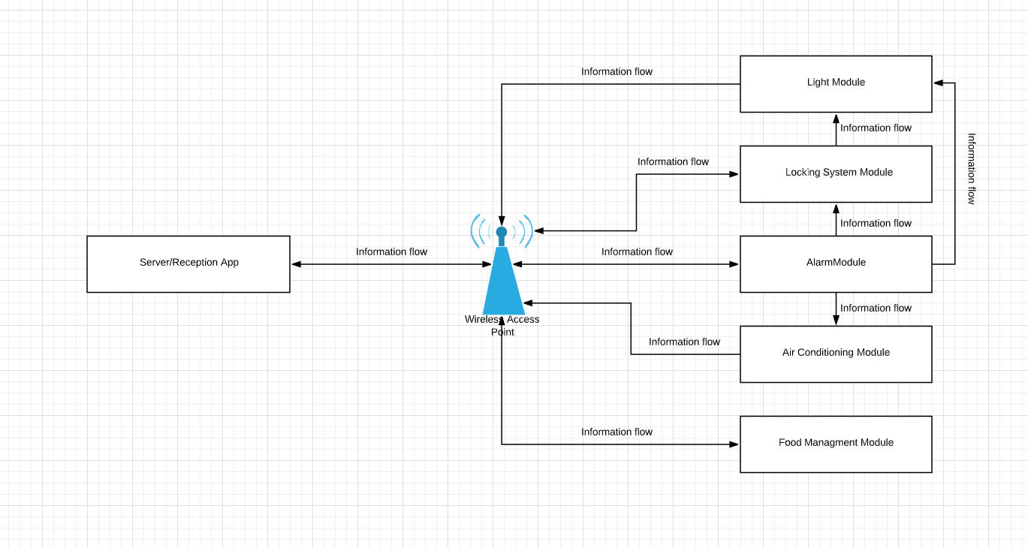

## Student House State Diagram:

Coming soon!!!

## Student House Flowchart:

Coming soon!!!

Expected Date 06.01.2020 !!!